RESTFUL API:

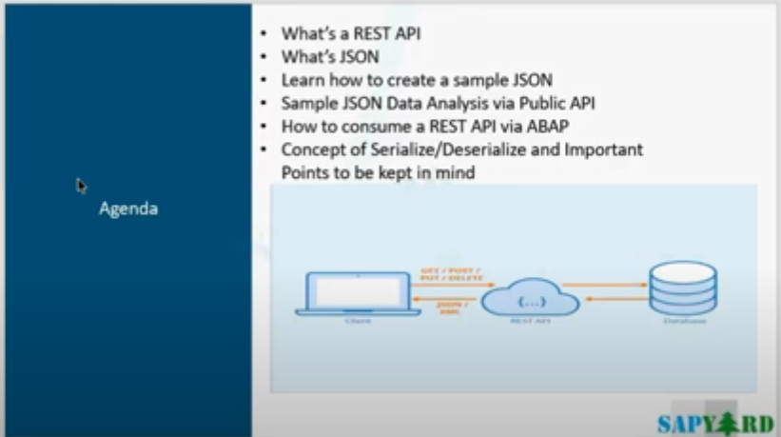

REST- Representational State of Data

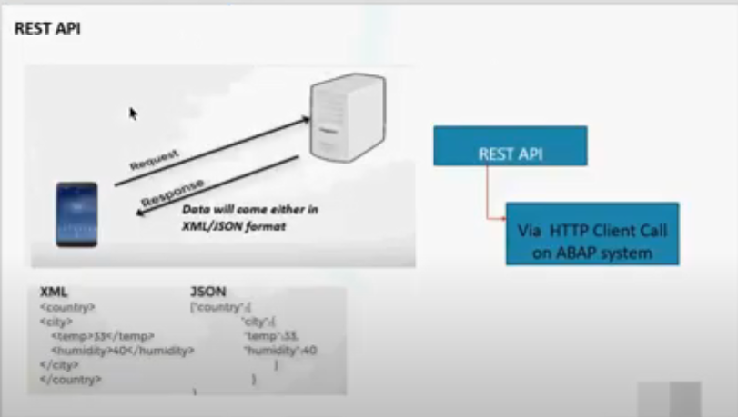

JSON Data:

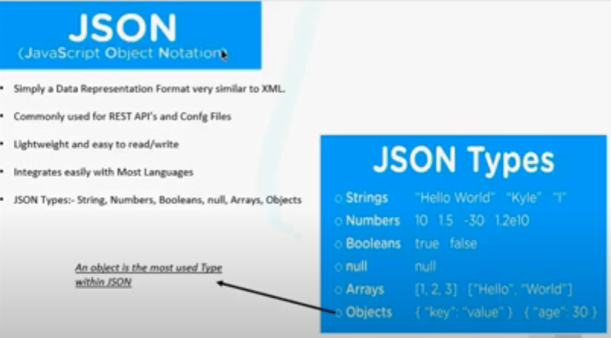

Mostly we have to focus on JSON, used transfer the data from client to server and server to client, json is very light weight to send the data to backend port and best part is human readability.

How to create the JSON?

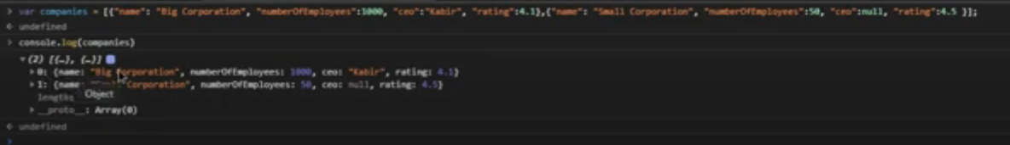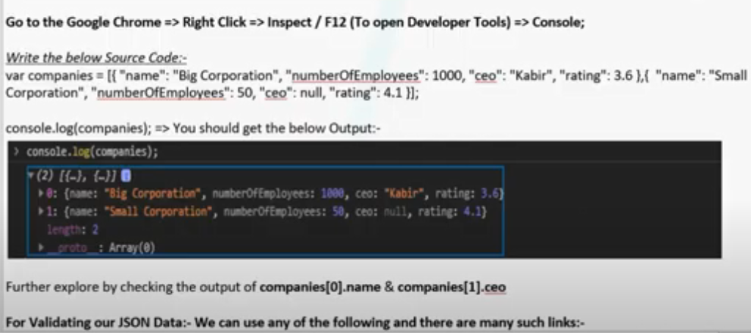

🡪sample api.

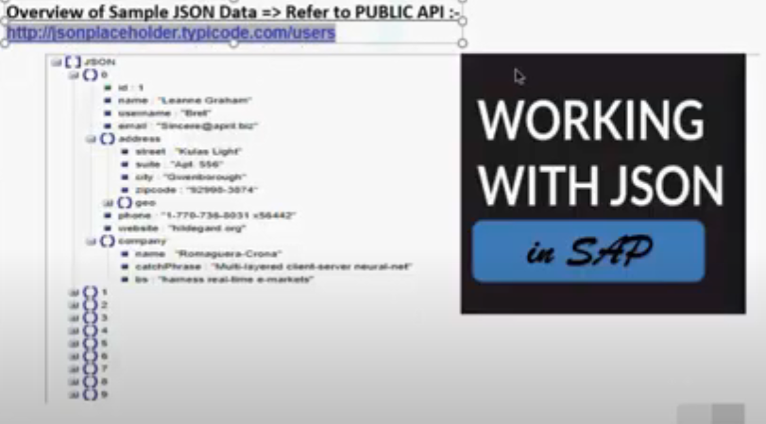

<http://jsonplaceholder.typicode.com/users> 🡪 API

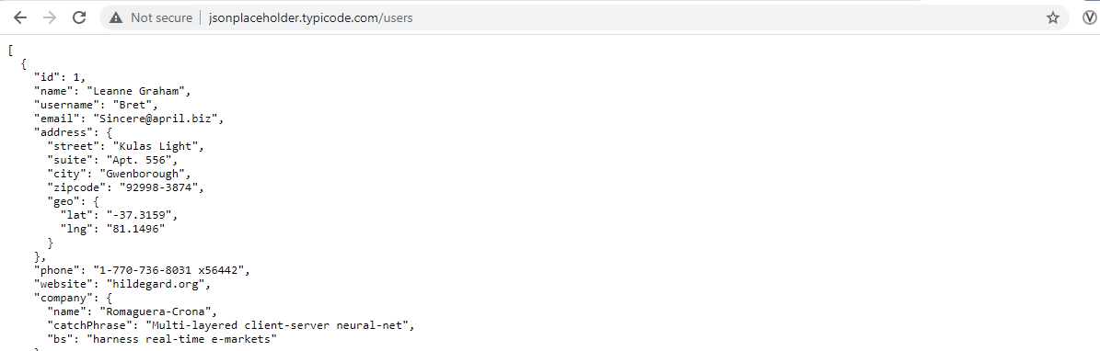

JSON Viewer:

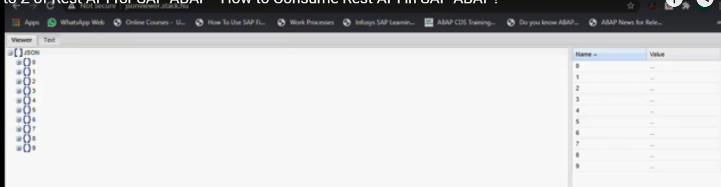

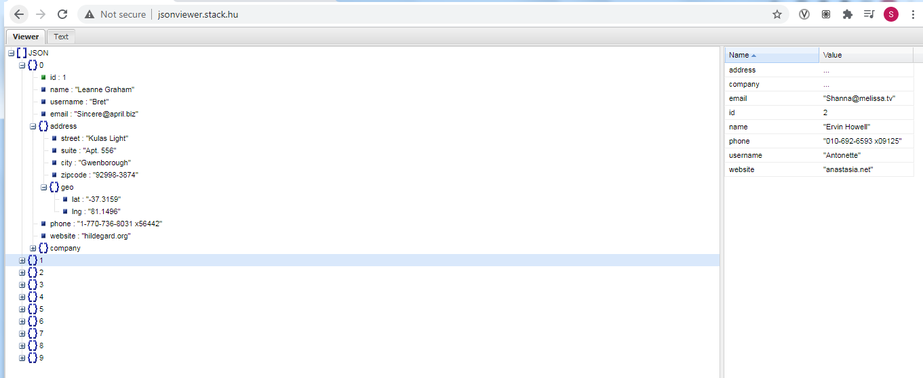

23:00

**How to consume the API in abap.?**

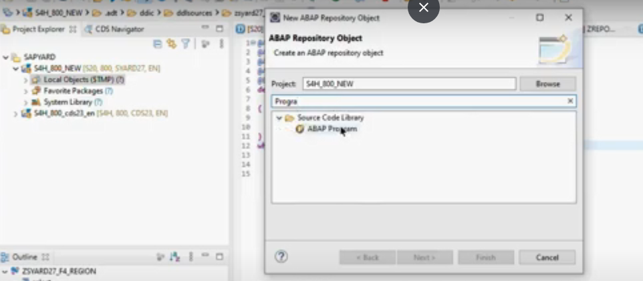

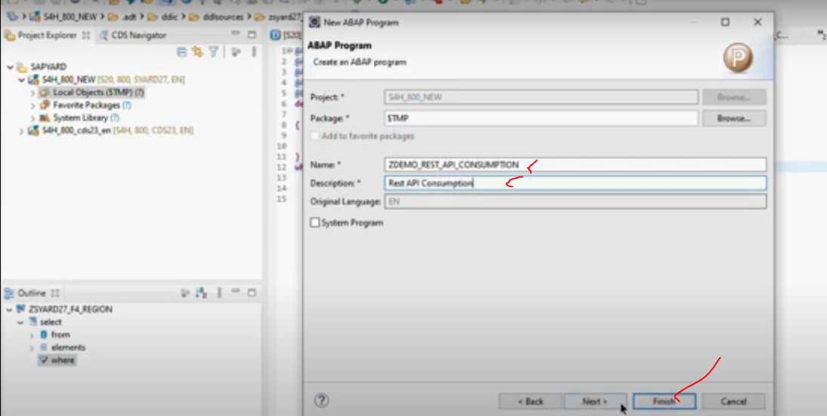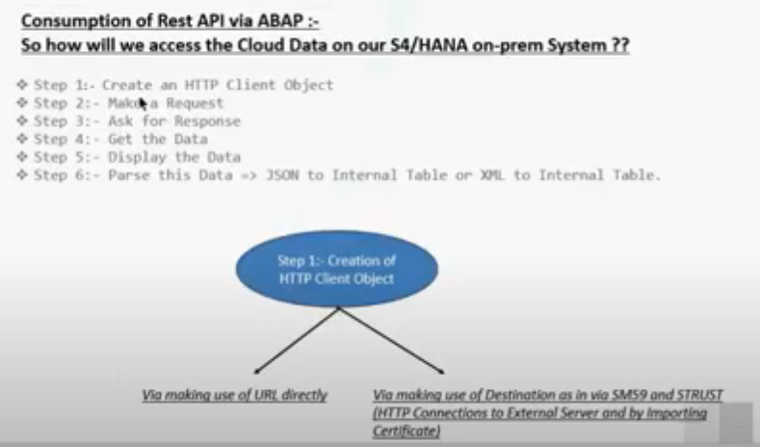

**Assign url to the variable**

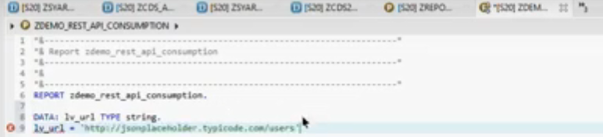

**or**

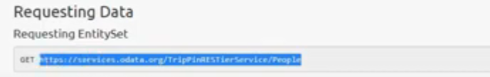

**Step-1 Create an HTTP client Object**

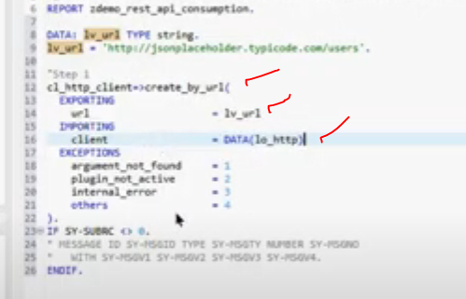

**Step-2 Make a request**

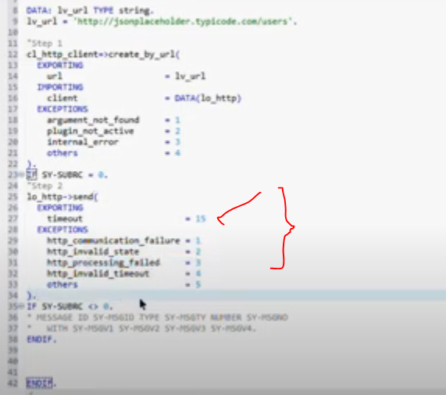

**Step-3**

**Ask for response.**

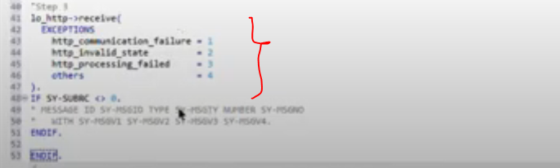

**Step 4 : Get the Data**



**Step 5: Display the Data**

**We will use the class : cl_abap_browser 🡪 to display the @browser**

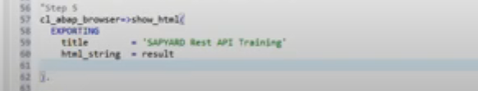

**Save and activate.**

**Execute:**

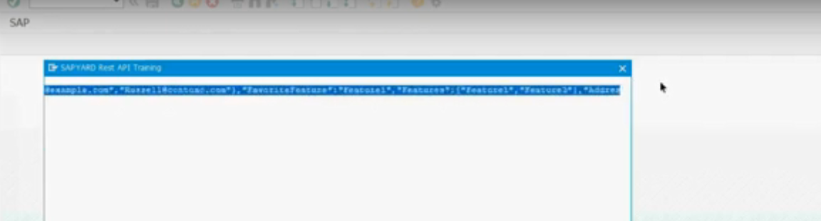

**We will receive the data is raw data.**

**How will handle this raw data making use of concept called deserialize (convert data into internal table)**

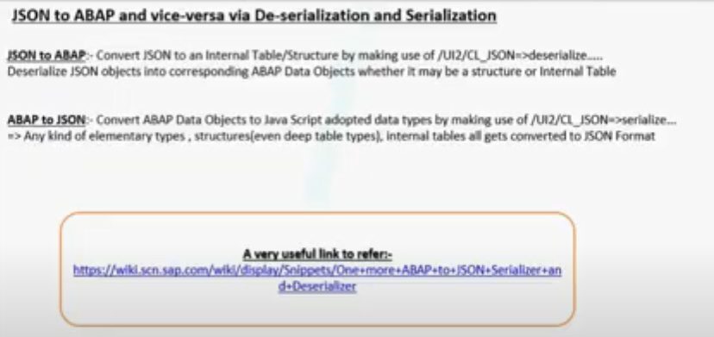

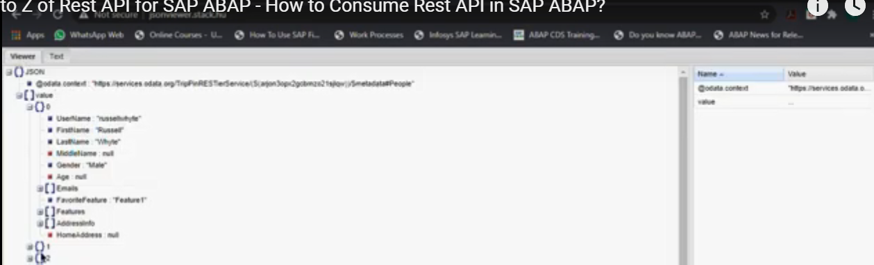

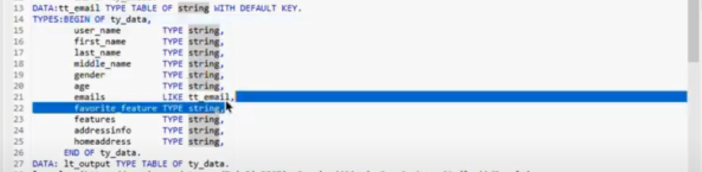

**Split the data to remove the first content.**



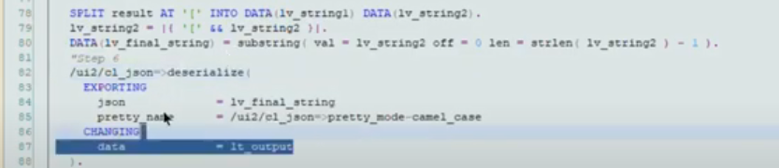

**Output**

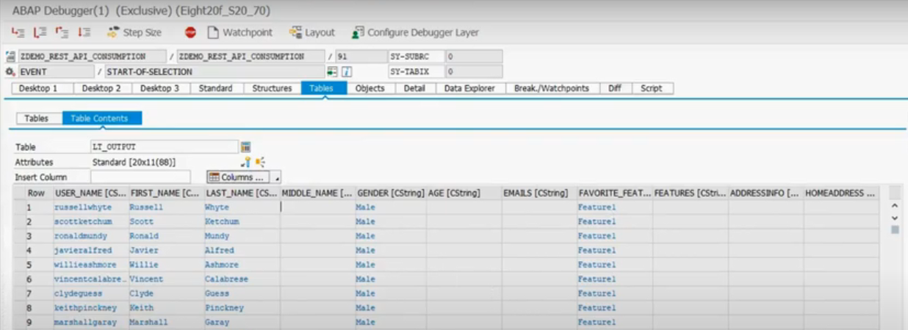

**Camel case represents through the”_” example: “user_name” means “UserName”.**

**Convert the data into json format:**



